COST ACTION C17: FIRE LOSS TO HISTORIC BUILDINGS 20.10.05

WORKING GROUP 3: CULTURAL AND FINANCIAL VALUE
cost17/wg313loss.authenti05

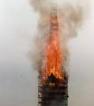 Bemgarten Kirche

WG 3.1.3

Principles of post fire decision making. (3.1 Cultural value)

Reconstruction or not if a fire has occurred has to be decided on deep knowledge about the value of the building from different aspects. To make reconstruction possible You have to be prepared with the right knowledge about the building. To save as much as possible You must have the right technical equipment on site and the fire brigade has to be informed. It has to be decided very quickly during the fire if You want to save the rests to be able to take care about them in the right way. To have money enough for all the building have to be insured in a proper way. That means that it is important to discuss the possibility of reconstruction and to what degree a reconstruction might be demanded before a fire occurs and to take the necessary steps to make it possible. Se also 3.1.4, 3.3, 3.4 and 3.5

The text below contains of a) summary b)National recommendation from Spain c)Case studies (Anna Amalia Library in Weimar, Arch Bishops Palace in Trondheim, The Bonde Palace Stockholm Sweden, The pier in Brighton UK, , Bryggen Bergen, Södra Råda Church Sweden, Uppark House England UK) d)Extracts from the Nordic project “Can we learn from heritage lost in fire” Åminneborg Maalahti mansion,- Kotaselkä, Savukoski logging hut Norway, - Tyrvää church Vammala,- City block Trondheim,- Innset church, - Eidsvoll church,- Ringnes farm Norway, - Södra Råda medival church, - City block Jönköping, - Katarina Barock church Sweden

a) Principles considering value, type of authenticity and degree of loss. Summary

Kerstin Westerlund Bjurström Arch SAR/MSA National Property Board Sweden

Fundamental for a decision about reconstruction of an historic building is knowledge about:
- Its cultural historic value
- Its emotional and economic value
- the possibilities to reach a successful reconstruction

The value of the building has to be analysed. The decision about reconstruction or not and about the appropriate extent of reconstruction will be different if the value is as:
- experience of old times through authenticity, the special feeling in an old building etc
- experience of beautiful, high quality architecture and art
or
- document over the past (structure, materials, technical constructions, architectural solutions, art, special quality etc.)
or
- symbol for an idea, a story, a tradition, or for -what it represents, - why it is built, - who built it, -who used it, -what was going on etc
- memory of an occurrence, activity etc
- landmark or part of an ensemble, step in continuity etc
or
- possibility to educate people in old building technics

Added value is given to the building if it is – very special, authentic or with strong identity – if it is typical.

To obtain a successful reconstruction it is very important to reconstruct the whole fabric of the building using the same material, the same construction etc as before the fire. It is not enough if the building looks the same on its surface. Than You will newer get the right feeling about it. It will also degenerate in a bad and wrong way. Very seldom new details, constructions or material are technically better than the old ones.
Many examples have showed that it is possible to reconstruct a building as landmark, symbol and as document from the past. To reconstruct an authentic feeling is very difficult and it is not possible at all to recreate real authenticity.

Proper detailed documentation is necessary if the goal is to obtain a satisfying reconstruction especially if the building is completely destroyed. In many cases also the property owners believe that their property is enough documented, but reality has shown that it is usually not

The degree of loss ( the whole building, part of it as a separate wing, one or a few rooms)
is of course a factor that influences on the decision to reconstruct or not or on the degree of reconstruction. But it is important not to begin with that. The discussion about the value and the possibilities must come first.

Practical aspects will effect the decision. There will be a desire for practical changes. New activities need different premises, laws about accessibility, security make demands etc The insurance create limits. Still a total reconstruction is not always more expensive.

Necessary steps to take in work process:
- Analyse the art of the value the added value (Cultural and practical)
- Consider the appropriate level of reconstruction
- Assume if it is technically possible to carry through a correct reconstruction
- Assume there are documentation enough to carry a reconstruction through in a correct way
- Try to find money

In many cases people believe that reconstruction is more expensive than new design. In many cases that is wrong

The action recommends that decision about reconstruction has to be based on analyse of:
- the art of the value (Cultural historic, emotional and economic)
-available knowledge about the building and the possibilities to create a reconstruction with the right quality regards to the situation. Se extraction below from Can we learn from heritage lost I fire.

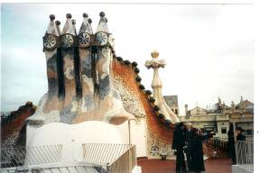Famous building by the architect Gaudi in Barcelona

b) National recommendations Example

The Spanish view on reconstruction Mariana Linares IETCC (CSIC)
In Spain there is not an “official document” about criteria of intervention in Heritage Buildings. Law 16/1985 on the Spanish Historical Heritage don’t state explicit recommendations, but it says that “public authorities shall aim, using all technical methods, to achieve preservation, consolidation and rehabilitation and shall prevent any attempts at reconstruction except when the original parts of the buildings are used and their authenticity can be proved. If materials or essential parts for stability or maintenance are added, such additions must be recognisable and confusion through imitation should be avoided”.

During the last years, many works of restoration have been carried out on stone fabric buildings in Spain. The Institute of Spanish Historical Heritage (IPHE) organised a workshop whose aim was defining basic criteria for the different stages of intervention on heritage buildings.

A group of 36 technical experts coming from research departments of several universities and the Spanish High Council of Science Research, as well as from different regional governments and the Spanish Association of Heritage Restoration Companies, discussed together with technical experts from IPHE about the research studies to be done before a reconstruction, during it, and after concluding it, about cleaning facades or about consolidation, reintegration or final protection of the restored goods.

As a result, they arrived to a consensus about several recommendations that need to be taken into account when carrying out an intervention project in general (not only for those cases of fire loss to historic buildings) for stone fabric.
In case of reconstruction, some of the recommendations to follow are:

- Structural and formal characteristics of the original building with its natural additions must be respected.

- As far as it is possible, written or graphic documents must give necessary information about the original aspect of the building.

- Once finished the cleaning process, the lack or loss of material don’t need to be replaced if it doesn’t affect the maintenance or the appreciation of the element and there is a cromatic and aesthetic integration.

- Formal reconstruction must concentrate on the replacement of the architectonic volume where needed, and it has to be easy to distinguish, but integrated in the whole. Mimesis must be avoided.

- There must be a tendency to use traditional materials and techniques and, as far as possible, the characteristics and nature of the material used for the reconstruction must be compatible with the original one.

- Reconstruction with mortar is only possible in case of small areas or volumes compared to the size of the original element, and when it doesn’t diminish its mechanical resistance.

- If structural function needs to be restored, stone must be used for the reconstruction.

Substitutions can only be justified when an element is so damaged that it can no longer carry out its structural or protective function, or when its preservation in situ is proved to be impossible. Possible damages generated during the substitution process must be assessed.

Linings over original stone surfaces used just with aesthetic purpose must be avoided. They must be limited to the integration of new natural stone distorting the final image of the whole.
A point of reference for those dedicated to the conservation of Heritage buildings in Spain are the definitions, recommendations and criteria defined in the Carta del Restauro (Italia 1972). Carta de Cracovia (Cracovia 2000) is maybe the latest update for these criteria.

c) Recreation versus modern replacement; Case studies

Anna Amalia Library in WeimarGermany Per Rohlen National Property Board SFV Sweden

On the evening of 2 September 2004 the Herzogin Anna Amalia Library in Weimar was severely damaged by fire.  Cultural historic value  The library, which is included in UNESCO’s world heritage list, was built in 1565 as a palace for Duke Johann Wilhelm. In 1766 the Duchess Anna Amalia converted in building in its entirety to a library. Another rebuilding took place at the beginning of the 19th century, when Goethe was the librarian (1797 – 1832)  The library contained approximately 110,000 books, mainly 17th and 18th vernacular literature, but also 11th century manuscripts, original scores, works of art, etc. 50,000 books were completely destroyed and 62,000 suffered fire and/or water damage. Some were saved as the fire blazed by staff and the public, who organised hand-to-hand chains. Items they succeeded in saving included the ‘Luther Bible’ from 1534.  Many of the damaged books are not rare and it will be possible to replace them. What made the books unique was that they were working material for Goethe, Schiller etc., whose own notes have been founding many of them.  Emotional value  The World Cultural Heritage site is something close to the hearts of the entire region.  Rescue operation  The fire started in the attic and spread to the floor below – the Rococo Hall - via openings in the joists.  The attic was in flames when the fire brigade arrived and, despite massive efforts by the regional emergency services, the building and its contents were severely damaged.  Technical fire protection  The emergency services were alerted by the building’s automatic fire alarm and a total of around 350 firemen were involved in the rescue operation.  The fire was confined to parts of the two upper storeys by a fire wall, the fire door in which was closed.  Intervention plan  There is a special intervention plan for the library, which governs what units are to be alerted, but when news of the fire spread, some units acted on their own responsibility, which caused a degree of chaos.  Urgent activities to protect the building  Since a great deal of water was used during the fire-fighting work, it was considered that there was a risk of collapse because the joists were overloaded. Technisches Hilfswerk (THW) made its technical resources available and, among other things, shored the building up.  Salvage work  The day after the fire the salvage work began. The building was emptied and all books were packed in plastic in chests for transport to the Zentrum für Bucherhaltung in Leipzig.  In Leipzig all damp books were placed in a freezer chamber (-21°). Freezing means that the damage is contained and there is more time for conservation.  Drying the books is done by freeze drying in a vacuum chamber. Conservation of the books is particularly complicated since the emergency services used foam to fight the fire.  Costs for restoring and replacing the books  The cost of restoring the books that are not a total loss is estimated at €20 million. The cost of replacing the restored books is estimated at € 47 million.  Restoring the building  All the attic was gone. The interiors in the Rococo hall one floor below was not destroyed by fire. Still the water make lot of damage in all the floors below. The panel work and the rococo decorations  Have to be taken away, dried during very special condition, some of them replaced by new made.  For sure the fabric of the building was more damaged than what was possible to see.  Post fire decision making  For sure it seemed to be a matter of course to save what could be saved both regards to the books and the buildings in spite of the huge costs. Both the cultural historic and the emotional value is enormous.  Still the decisions have to be very quick. Both the practical activities and investigations to find the correct treatment of different materials have to start at once | 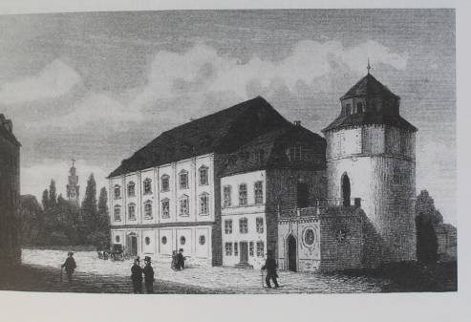  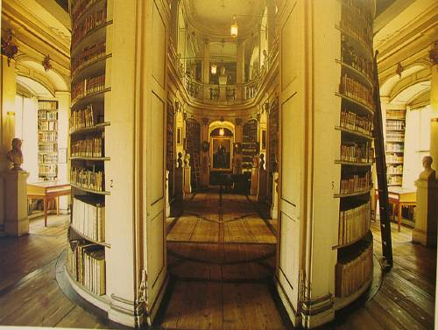  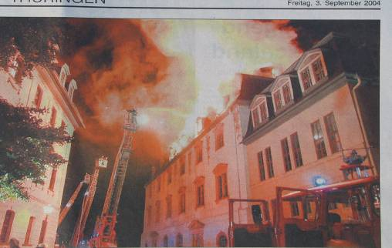  Picture: TLZ  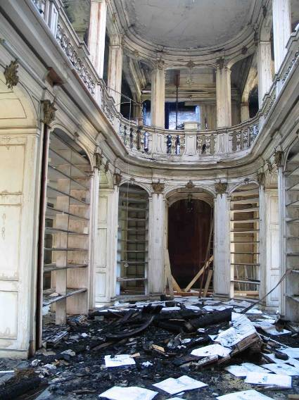  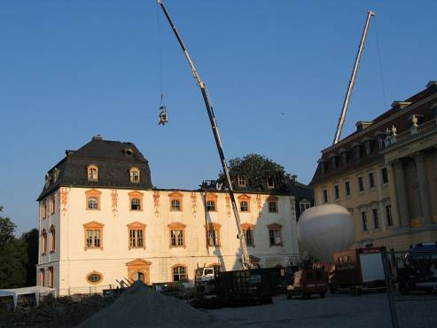  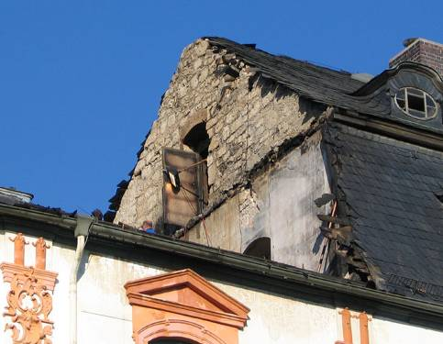  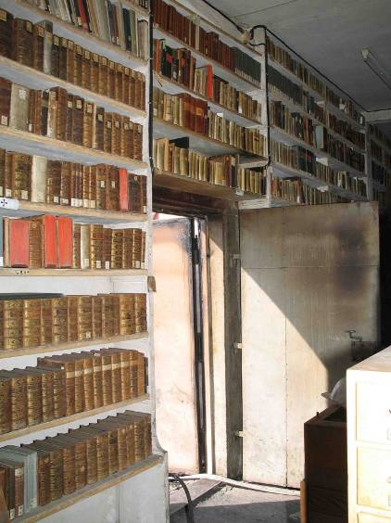  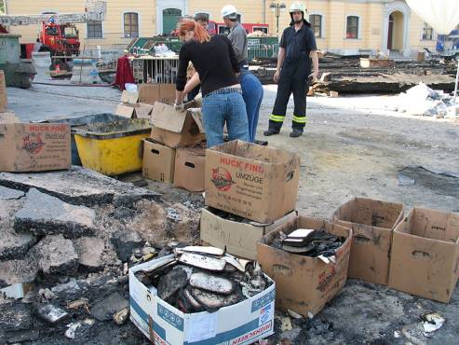  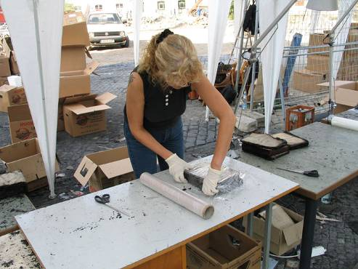

Many of the books in the Anna Amalia library were supposed to have been moved to a newly-built underground facility in February 2005, i.e. 5 months after the fire – a facility that is protected by water sprinklers.

Archbishops Palace in Trondheim, Norway. Einar Karlsen Directorate for Cultural Heritage
The Archbishop’s Palace in Trondheim was built during the 12 and 13th centuries as a seat for the archbishop of Norway responsible for a large province with 11 bishops. It was an important economic, religious and cultural centre in northern Scandinavia. After the reformation the buildings were used as residence for the representative for the king of Denmark. Later it was used as offices and depots for the military. In 1915 The Archbishops Palace became a national monument. Restoration of The Archbishops Palace was carried out from the 1950ies until 1975.

The east and south wing of the Archbishop’s Palace in Trondheim was destroyed by fire in 1983. The buildings were built ca. 1800 mainly in wood and originally mainly used for storage. After the fire, the state committee responsible for the Archbishop’s palace envisaged a more active use of the buildings. An architectural competition was held to decide how to reconstruct after the fire. The jury used as one of the main arguments for choosing the winning project, that the main building in the north wing retained a domineering position in the complex. The new south and east wings have pitched roofs and are covered with red tiles as the other buildings. The red brick facades have a modern architectural expression. With their proportions and subdued architectural details they blend well in with the old buildings. The new buildings at the Archbishop’s Palace were finished in 1997. The new buildings contain a museum for the Archbishop’s Palace in the south wing, and offices for the bishop and a multi purpose hall in the east wing. Structures uncovered during the archaeological excavations, as a unique medieval coin workshop, are preserved within the building complex. The original outer wall is running through the whole ground level.

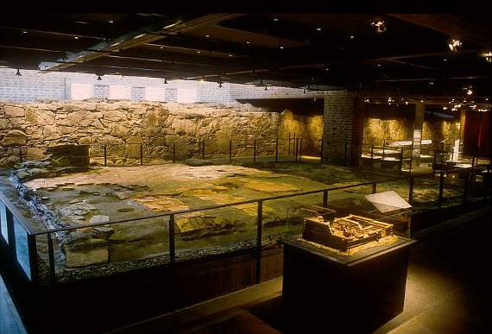
The Archbishop’s Palace in Trondheim. The medieval coin workshop and the original outer wall are preserved within the new building complex.

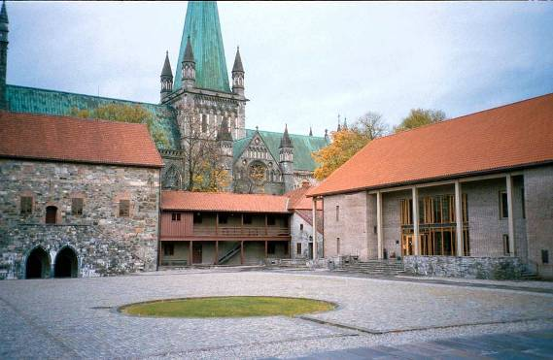

The Archbishop’s Palace in Trondheim. The main building on the left and the modern building reconstructed after the fire to the right. The same roofing material and a subdued architectural language with modest openings in the walls makes the new buildings blend in with the old.

The reconstruction of the Archbishop’s Palace in Trondheim after the fire in 1983 created less controversy than in Bergen after the fire in 1955. The owner was a public body and therefore did not have the same demand for economic viability. Changing architectural fashions and attitudes towards conservation made it natural to choose buildings that blended in with the existing after the fire in 1983. In recent years architects and conservators have favoured more contrast. In June 2006 a new visitor centre opened next to the west front of the cathedral. This building has a more modernist architectural language with flat roofs and an extensive use of glass.

References
Erkebispegården Vestfrontplassen Trondheim. Statsbygg 1997

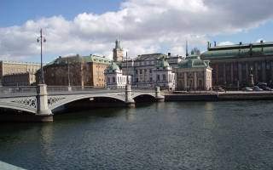 Bonde palace in Stockholm, in the middle

Bonde Palace Stockholm; hypotethical decisions of how to act after a fire; Evaluation as part of risk assessment document Kerstin Westerlund Bjurström National property Board SFV Sweden
A private palace from 17 th century, today used for the Supreme Court of Judicature in Sweden. It is one of the most important architecture monuments from Sweden as a great power etc It is a national monument part of Swedish national heritage owned by National Property Board. It is situated in the old city center close to the water seen from many directions. Its interiors are of varied interest. They have changed quite o lot, but parts also of a late renewal is valuable. There are some valuable movables in the building

The need of expensive fire prevention vas questioned by the decision maker. The building is not insured by a private company making demand on fire prevention. The property manager therefore had to find out what the maximum rebuilding costs would be in case of fire to be able to relate it to what would be appropriate fire prevention. That made it necessary to discus and decide about a hypothetical level of reconstruction.

In short it was decided;
“After a fire the assumption must be to recreate the exterior as a whole, the main entrance, entrance halls and rooms classified as 1 must become reconstructed with the same materials, form, colours and decorations as from their origin. Rooms classified as 2 and 3 must get the same quality as the origin”

“Valuable rooms in the building must have special plans for their protection and be handled in a special way by the fire brigades. Of special value are entrance halls, corridors and staircases, session chambers, Bonde´s workroom nr 18 and room nr 48 with parts from 17 th and 18 th century”.

From that You can that all parts of the building do not have to be reconstructed in the old way. In the interior large parts of its fabric can be changed to modern constructions, material and design.

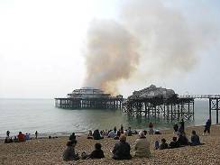

The pier in Brighton English Heritages research project about decision making
“A report into recent practise following catastrophic damage at historic places, with particular reference to Brigthons west pier”. Dr Rickard Morris Summary, Kerstin Westerlund
Following fire damage to both the pavilion and the concert hall at the West Pier in spring2003 English heritage in a very ambitious way analysed the different aspect on how to go ahead. The main issue of consideration by English Heritage was what framework to use to re-evaluate the situation following the fires. A process of comparison was carried through, so that the advice would be consistent with similar circumstances elsewhere.. It was also important that English Heritages advise was situated in the context of international approaches to conservation in the twenty- first century.

English Heritages policy on repairing historic buildings from Christopher Brereton` s book 1995 was found to be inappropriate. It was found that the Riga ICOMOS Charter on Authenticity and historical Reconstruction in relationship to Cultural Heritage Charter addresses more directly to the sort of dilemma in Brigthon.

Article 6 of the Riga Charter advises that:
In exceptional circumstances, reconstruction of cultural heritage lost through disaster, whether of natural or human origin, may be acceptable when the monument concerned has outstanding artistic, symbolic or environmental significance for regional history and cultures(or) when used as an administrative measure to fight against purposeful destruction of cultural heritage provided that:

a)appropriate survey and historical documentation is available

b)the reconstruction does not falsify the overall urban or landscape context;

c)existing significant historic fabric will not be damaged; and
providing always that the need for reconstruction has been established through full and open consultations among national and local authorities and the community concerned.

English heritage believes that the three tests of the Riga Charter provide an internationally validated framework for the re evaluation of the proposals for the west Pier.

English Heritage uses definition as follows:
-restoration means returning the existing fabric of aplace to a known earlier state by removing accretions or by reassembling existing components without the introduction of new materials
-reconstruction means returning a place to a known earlier state and is distinguished from restauration by introduction of new material into the fabric
-recreation means speculative creation of presumed earlier state on the basis of surviving evidence from that place and other sites on deductions drawn from that evidence, uring new materials.
-replication means the construction of a copy of a structure or building, usually on another site or nearby.

Philosophical approaches
The philosophical approaches lying behind Brereton and older English Heritage policy was the very English Ruskinian- Morrisan tradition of conservative repairer. Although deeply ingrained in English architectural and conservation discourse, it is important to realise that conservative repair has not been and is not the only philosophical approach to conservation. While Ruskin and Morris were essentially interested in fabric, in buildings as examples of craftsmanship, violet was much more interested in them as designs, as works of the art of architecture.

The Burra ICOMOS Charter suggested cultural significance as a concept which helps in estimating the value of places, which help an understanding of the past or enrich the present, and which will be of value to future generations.

Philosophy and practice
Usually authenticity of fabric was the first concern in the repair after damage. A result of that full reinstatement has not offen been discussed. Many examples are given in the report.

But at Uppark house, the owner National Trust had full insurance for repair and focused at the fact that the contents from the most significant interiors that had been open to public survived and therefore decided the interiors to be fully repaired to their condition before the fire. English Heritage used the same argument after the fire at Prior park. At the Baltic Exchange in the city of London they didn`t succeed because of the variable value of the building and the site-value.

Windsor castle represent a milestone in English conservation. The repair of the State Dining Room and the Octagon Dining Room are major exemples of re-instatement of buildingsor interiors vwhich had been completely consumed by fire. The arguments against proposals for contempory redesign was that the area that Whyatville remodelled, before the fire, was a superb and unrivalled sequence of rooms widely regarded as the finest and most complex expression of later Georgian taste

The dominant paradigm for English heritage`s response to disasters at histiric building has been conservative repair but that the solutions in each case have not been dogmatic.

The west Pier
Its significance is largely visual and its reconstruction can therefore be said to be important in terms of the visual qualities of the place.
Like other architecture of the entertainment industry, the architecture used was intended to be splendid and lavish rather than earnest. Their most important purpose was to be attractive in commercial terms. Slavish adherence to the materials used to create effect would be superfluours. Indeed one could fairly argue that, just as the repair of the State Dining Room was based on its importance as a decorated surface, and not as a structure with depth, it would be valid to consider the two pier buildings as little more than decorated shells.. As the interior of the buildings at the time of the fire was of little interest, external repair of the shells was regarded appropriate, a reconstruction wich ignores authentic repair.

The Riga tests
The first step is to confirm that the pier is of outstanding significance
-it’s a culmination of a development of pier
-it is the most elegant pier structure in cast iron and timbers
-architectually it was of greater aspiration than these before
-socially very important as activity place

It was sufficiently photographed and drawn. Its nature as as a prefabricated building means that much of the structure can be replicated from stored parts etc

Second step is to test that the reconstruction not falsifies the landscape context. It does not. It is no reason to let it stand as a ruin to commemorate the fire rememberence. Third step is to test that existing fabric of importance will not be destroyed by the reconstruction. It will not.

Conclusion
The fire did not effect the key significance of the pier. It is the most important pleasure pier ever built in terms of engineering design, - architectural ambition, -social symbol

English Heritage also recommend that as much surviving salvaged fabric as is practicable should be incorporated into the repair and restoration of the substructure and deck furniture, both to preserve at least some historic character of the pier and to act as guarantor of exactityde in any replacements.

Nonetheless, high standards of accurancy in the reconstruction of the exteriors should be demanded

Bryggen in Bergen, Norway Einar Karlsen Directorate for Cultural Heritage
The history of Bryggen goes back to the 12th century as a trading centre for the export of dried fish. From the 14th century it was taken over by the Hanseatic League. There were frequent fires on Bryggen. In 1702 the whole area was totally ravaged by fire. Most of the buildings date from after this fire. In 1979 Bryggen was inscribed on the Unesco World Heritage List.

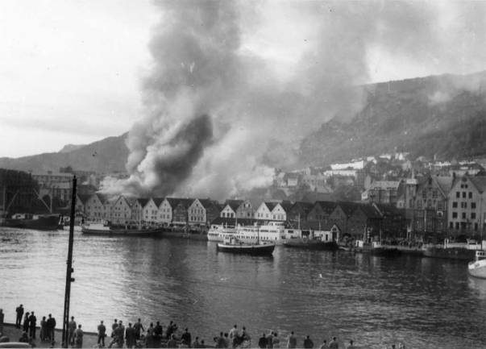

The fire on Bryggen in Bergen in 1955. Bryggen is now a UNESCO World Heritage Site.

Half of the buildings on Bryggen in Bergen burnt down in a fire in 1955. As the buildings were in wood, the area suffered total destruction. The buildings that burnt down dated from after the fire in 1702, but had the same function and similar construction as in the Middle Ages. Extensive archaeological excavations were carried out after the fire in 1955. Before a total plan for the area was ready, an archaeological museum was built on Bryggen. The Bryggen Museum opened in 1976 as a modern design with flat roof and exposed concrete facades. Some of the structures uncovered during the excavations are preserved inside the new museum building.

Rebuilding the area after the fire was a lengthy process. Reconstruction of the whole building complex as it was before the fire was not realistic. The available documentation (drawings, photographs etc.) was not regarded as sufficient. Daylight requirements and access for the fire brigade were other factors that made reconstruction of Bryggen as it was before the fire difficult. Reconstruction of Bryggen in wood would also have made it difficult to satisfy modern fire regulations. Bryggen Museum was already built as a modern concrete building.
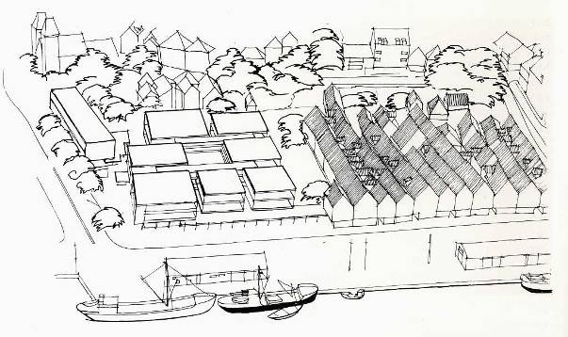

Project for a shopping centre on Bryggen. Aall and Løkeland, architects, 1962

The initial plans for reconstruction were a shopping centre with passageways emulating the layout of the old Bryggen but as strictly modernist buildings with flat roofs. New owners of the site discarded the original plans in favour of a hotel as they did not regard the shopping centre as economically viable. They wanted to expose the hotel with a modern façade facing the harbour. In 1974 the Directorate for Cultural Heritage, however, launched the idea of reconstructing the burnt down sea-front facades. As a compromise the architects came up with the idea of connecting the wooden structures along the sea-front and the modern hotel behind it with a glass-covered internal courtyard. The hotel was completed in 1983, echoing the old building structures on Bryggen with long parallel buildings with steep pitched roofs. The architecture and use of materials are, however, modern with brick cladding. On the seafront the buildings were constructed in timber but with concrete foundations. A repetitiveness found in the old Bryggen was aimed for in the new buildings. The reconstruction of Bryggen has been criticised for being a pastiche, a modern hotel pretending to look like wooden warehouses. But the hotel had its supporters and was awarded The Europa Nostra Award for successful infill architecture in 1984.
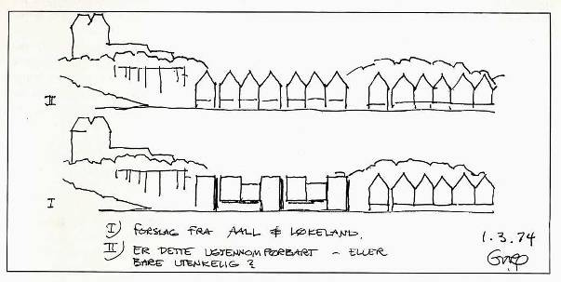
Sketches with two different alternatives for reconstruction after the fire on Bryggen in 1955. Ola H. Øverås, the Directorate for Cultural Heritage, 1974

In the buildings that were saved in the 1955 fire extensive fire protection measures were carried out. In 1964-65 all the buildings were equipped with internal and external sprinklers. During the 1990ies fire detection was installed with direct link to the fire brigade. The sprinkler systems have prevented at least five smaller fires from spreading to the rest of the area. Most of these fires were caused by arson. A controversial fire protection measure was the demolishing of buildings at the rear of Bryggen, creating an internal street as a fire barrier.

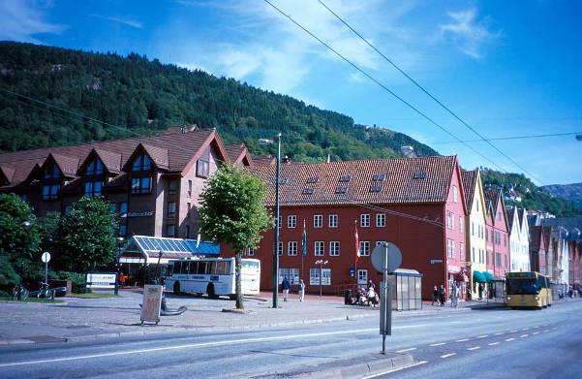
The area on Bryggen as it was rebuilt after the fire in 1955. On the left the SAS Hotel. It has modern brick facades but roofs trying to emulate the old Bryggen. To the right the buildings along the sea front in wood with copies of the original facades. Partly hidden behind the tree in the middle is the glass covered link between the hotel and the buildings on the sea front.

References
Asbjørn Herteig. Bryggen fra saneringsobjekt til internasjonalt kulturminne. Vigmostad og Bjørke AS 2005
Dag Myklebust. Bryggen i Bergen: Tilpasningsarkitektur-eller bare passende pastisj? Universitetsforlaget 1988

Södra Råda Church Sweden PPPresentation Thomas Erenmalm National Heritage Board

The church was burnt down totally after an arson in 2001

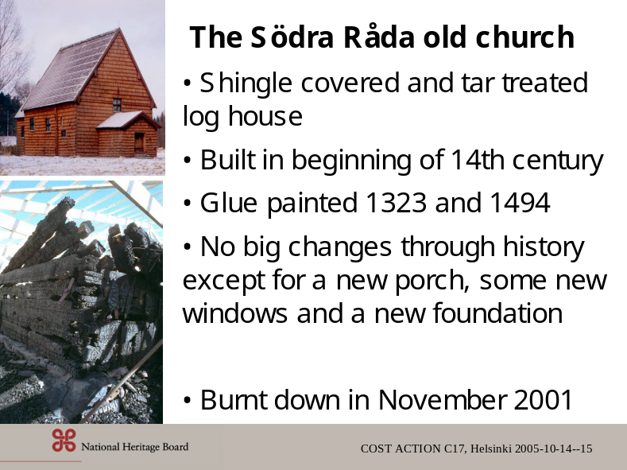

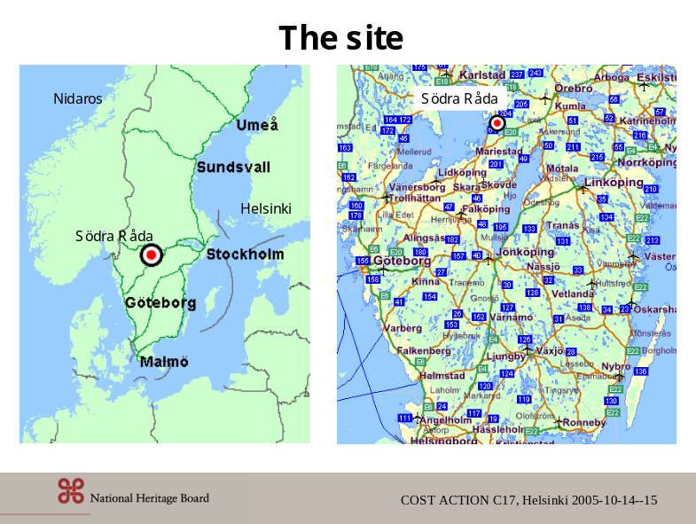

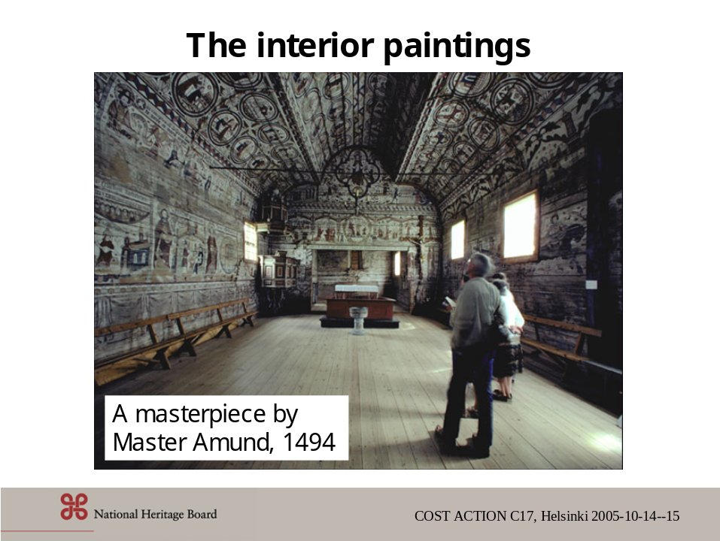

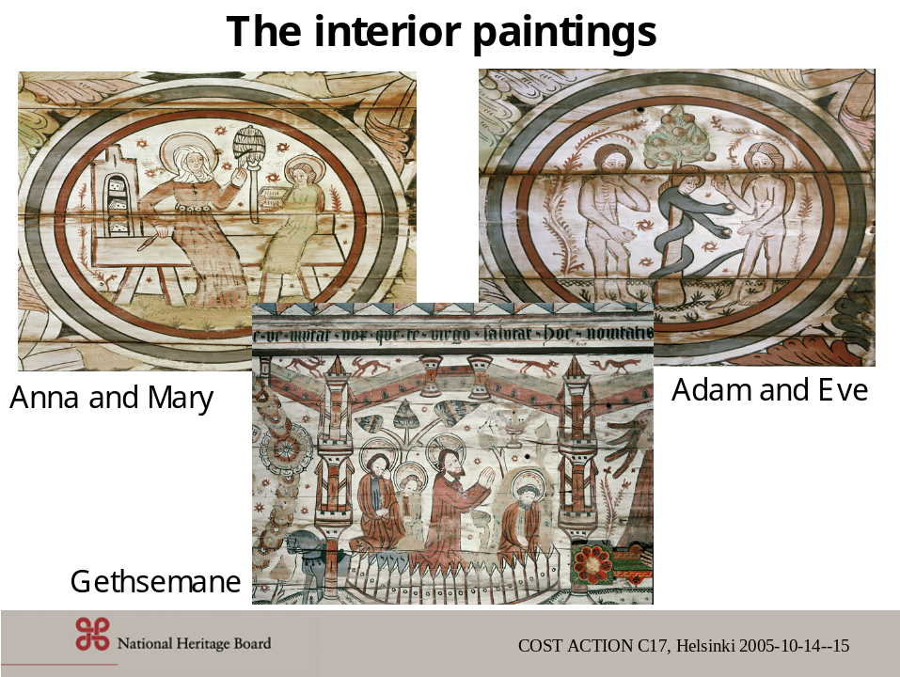

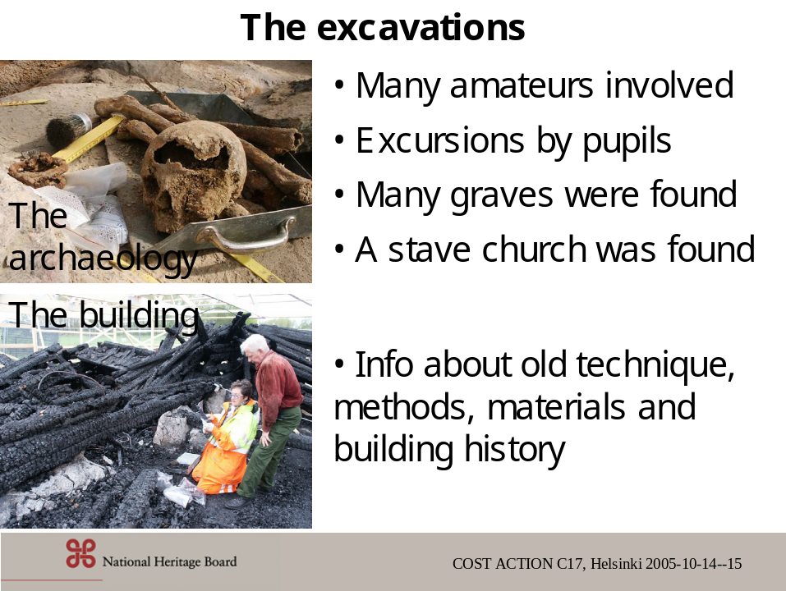

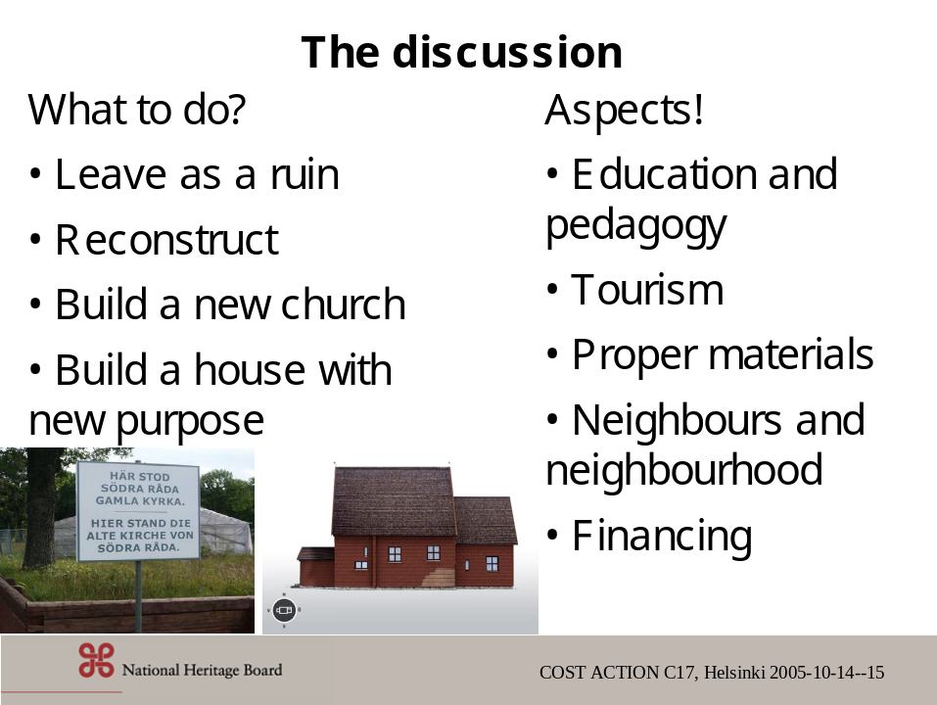

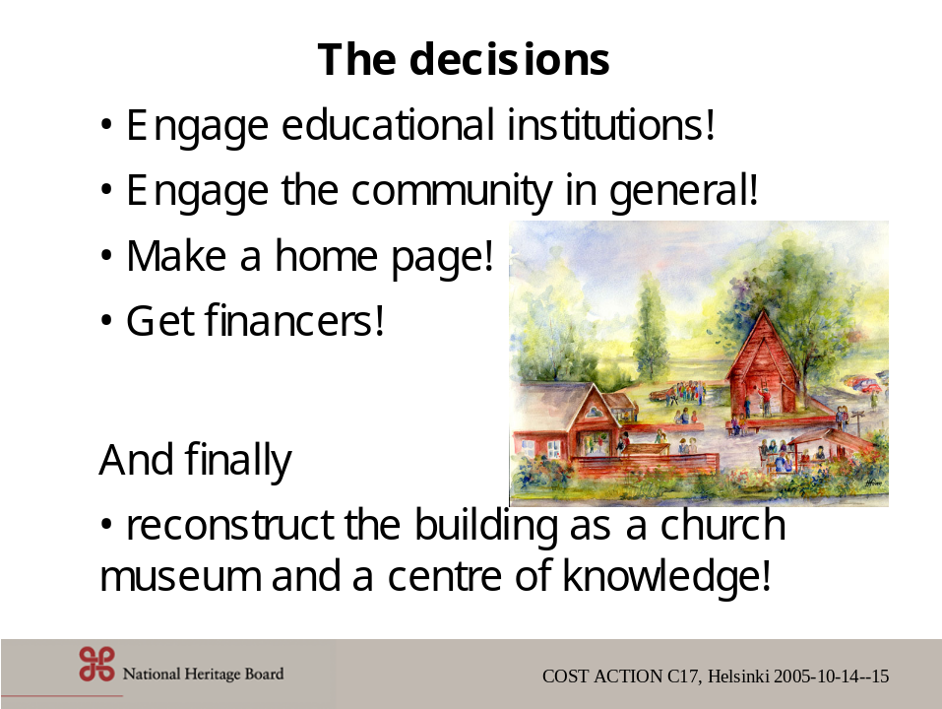

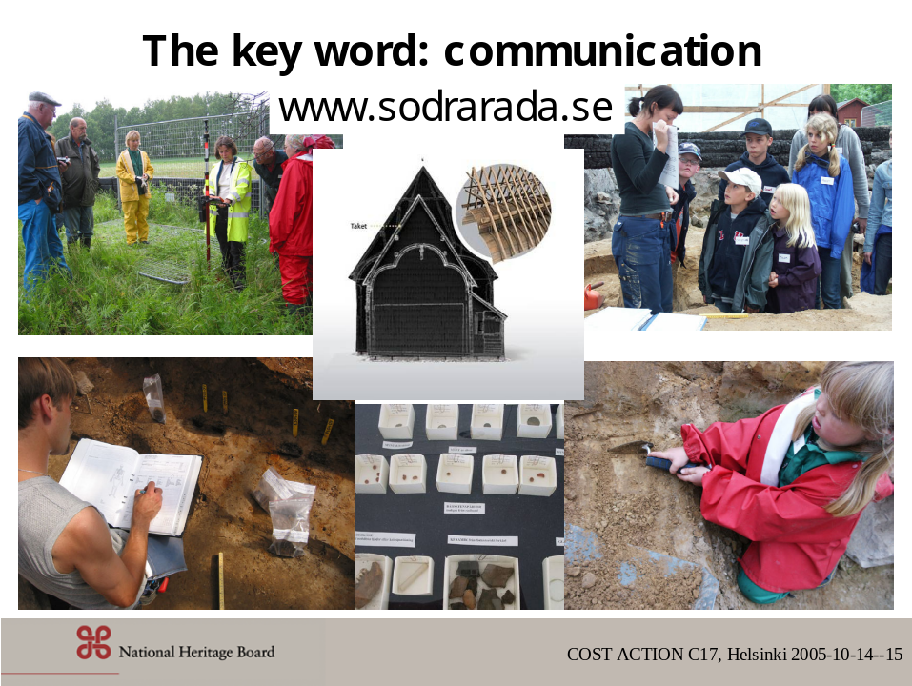

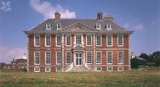 Uppark House English Heritage

Uppark House Recreation vs. modern replacement after fire United Kingdom

This decision was based on practicalities.

- The outer walls, most of the ground floor rooms (about 70 per cent of the original fabric, The National Trust decided to restore Uppark to its appearance of ‘the day before the fire’. including 90 per cent of metalwork and 65 per cent of the textiles) and all the basement remained. The scaffolding that surrounded the building for the benefit of the roof workers ensured that the outer walls were still stable.
- Uppark is a grade 1 listed building and English Heritage would simply not have consented to its total demolition.
- Retention as a ruin was not practical. The best way to preserve a shell, especially one built of brick and lime mortar in England (where it rains) is to protect it with a roof so that only the exterior walls get wet. To have created a new interior within the preserved shell would have involved the destruction of the substantial parts of the surviving part of the ground floor interior and would have provided an anachronistic setting for the collection. The grant of Listed Building Consent would not have been forthcoming from English Heritage.
- The building was comprehensively insured for total reinstatement. The insurance money could only be used for the rebuilding and repair of Uppark and not for any other purpose.
- The National Trust, a champion of the historically authentic, non-museum display of works of art, considered it important that the contents, which had been designed or purchased specifically for the house by two generations of discerning Georgian collectors, should be seen again in their natural surroundings. 95 per cent of the contents of the state rooms - pictures, furniture, ceramics, carpets, books, and so forth – had been rescued during the fire and could be put back in their original positions. Partial restoration of the interior would have greatly reduced its quality as a setting for the eighteenth century collection. Each part of Uppark contributed to a greater whole. Wilfully to have omitted the destroyed parts of the original architecture would have turned the house into a museum display. What would have been gained, for instance, by giving the Saloon a plain ceiling or leaving the north wall of the dining room as bare brickwork, when the rest of the rooms and their furniture, pictures and other fixtures and fittings had largely survived or were capable of repair?
- Finally. Uppark was well documented, with a detailed photographic record of the main rooms, as well as thousands of fragments retrieved after the fire, furnishing evidence for their full reinstatement. The rescue, sieving and recording of nearly 4000 dustbins had provided a basic catalogue of all the salvaged material, from primary floor joists to small nails. The National Trust had also commissioned a complete photogrammetric survey of the surviving structure. As a result of this, the evidence was available for an absolutely accurate reconstruction of Uppark, incorporating everything that had survived the fire.

The architect for the National Trust was instructed that the house was to be rebuilt to match its appearance of the day before the fire and that the reconstruction should incorporate conserved remnants wherever possible, but subject to strict commercial scrutiny. The latter was a requirement of the Trust’s insurers, who insisted on the most economical approach. Their loss adjusters insisted that original components should only be reinstated where it could be shown that it was no more expensive to do so than to make a replacement of equivalent quality. In the event it proved consistently cheaper to reuse old work wherever practicable rather than to copy, even allowing for the cost of initial repair.

The Trust’s decided that this principal applied to the architecture and decoration, but that all services would be modernised and the most advanced heating systems, humidity control, fire detection and security technology would be discreetly introduced.

d) ”Can we learn from the heritage lost in fire” Finland, Norway, Sweden
“Before any decision is made, the situation and the existing documents and knowledge on the burned building should be thoroughly analysed. If rebuilding is chosen, there might be a need for research or experimentation before applying certain constructions, materials or techniques. Rebuilding can be seen as a possibility to learn about old techniques and materials, but this kind of work needs more time than normal.

It was interesting that both The Katarina and Tyrvää Churches were dominant in the landscape and their silhouettes were so important that this point of view was used as justification for rebuilding.
Another justification for the Katarina Church was that it was very actively used. In the Tyrvää case, the church was not used so much before the fire but it became very popular after (and during) its rebuilding.

Things that should be analysed before a decision is made:
- the meaning of the building for the surrounding area or landscape
- the value of using the building (is it still needed)
- existing knowledge on the building (level of documentation)
- the possibilities of rebuilding (economics, skills, techniques, materials)
- the effects of rebuilding (mental, economic, educational, research)
- the style of rebuilding (copy, interpretation, new design, mixture)
- the effects of not rebuilding”

What the law says
It can be told very roughly. If the building is totally destroyed You do not have to restore it. (But there can be other reasons to do so). If a building is partly destroyed you have to discuss what to do with the antiquarian authorities. You can be obliged to reconstruct it with the same material , construction and fabric etc

Case studies; Recreation vs. modern replacement (Decision process occurring after fire - recreation or modern)The Nordic project ”Can we learn from the heritage lost in fire”:

1. ÅMINNEBORG, Maalahti, Finland
This is a wooden mansion with a cellar, two living floors and an unheated attic totalling 500 square meters. It was built in 1792. The construction is made of logs. Most of the original interiors were destroyed between 1936 and 1964. The oldest wallpapers still existing are probably from the 1820s (but are covered with later layers).
Fire alarms were only installed on the living floors and not in the attic, which was used as storage.

After the fire
The result of the fire was that all the roof structures and the attic were badly charred and the attic floor support beams were badly damaged. The ceiling, walls and the floor of the second living floor were badly damaged because of the amount of water used by fire fighters and there was also damage to the first floor.

There was no real documentation of the remaining structures of the roof. The only documentation was a series of photos showing the situation after the fire.

The building was not insured properly but the owner wants to build the roof anew. He has asked the National Board of Antiquities for help. The idea is to keep the old shape of the roof using a new structure. The new attic will also be heated and not a cold attic as it used to be. Another addition will be two new attic windows.

What can be learnt?
It is important to check old electrical installations regularly and to consider the effects of heating previously unheated spaces. In addition, it is important to have fire detectors in all spaces, particularly in the attic. Fire brigades should have information concerning historic buildings in order to act correctly. Remaining structures should be documented as this might have revealed something interesting about the wood joints or other details in the roof construction. A fire can provide a researcher with an opportunity to find something that is normally invisible and unobtainable.

2. KOTASELKÄ, Savukoski, Finland
This was the site of a simple logging hut about 30 km from the centre of Savukoski in Lapland. It was made of logs and had a shingle roof. The building has a floor area of about 250 square meters. It was built in the 1950s and fully renovated at the very beginning of 1990s. The first building on the site was from the 1930s and it was burnt during the war in the 1940s. The building from 1950s was not an exact copy of the old one but an "improved" version.

The building was not regularly heated but there were stoves and fireplaces for heating. There was no kind of fire alarm system in the building and no electricity. The building was protected by the act concerning buildings owned by the State.

After the fire
The building was totally destroyed by fire in June 2001. There was no documentation of the remains after the fire. A few people from the National Board of Antiquities visited the site soon afterwards and they took some photos. It would have been possible to document the location of floor beams and the system for the foundation as well as the types of ovens using drawings and to document the dimensions and type of the wood material used in the lowest logs.

After the fire, it was checked if there was any material (drawings, photos etc) on the building in the archives of the Museovirasto. Only one drawing (a plan), a few photos and some written documents of the renovations in 1990s were found and it was decided that rebuilding the hut was out of the question. A year later, the archives were searched again and some twenty good quality photos were found. There were pictures of the interior and facades. Also found were drawings to a scale 1:50 showing the plan, facade and one section of the hut.
There was lot of discussion between the owner (the Museovirasto) and the user (the Savukoski municipality) about whether should the building be rebuilt. The insurance would have covered the cost of rebuilding, but the idea of reconstructing a lost building is unpopular the Museovirasto. Finally, it was decided that the logging site hut would not be rebuilt but the money from the insurance would be used to restore other historic buildings owned by the State in the municipality of Savukoski.

What can be learnt?
The fire might have been avoided if there had been a dense net in the chimney to prevent sparks from flying onto the roof. A very loud fire alarm might have made the fishermen notice that the hut was on fire and they might have been able to fight the fire.

Good documentation after the fire should have been made to document the remains. In addition, a thorough examination of the archived material should have been carried out immediately after the fire in order to give proper bases for the decision of whether to rebuild the property.

3. Tyrvää Church, Vammala, Finland
The church in Tyrvää was built in 1490-1530. It burned in the 17th century but it was rebuilt again in a slightly different form. Its interior was renewed in the 18th century. The old church was discarded 1855 when a new bigger church was completed - it was even used as a hay barn until its value was rediscovered by one of the Art-Historic Expeditions made by the Finnish Archaeological Society at the end of 19th century. The church has stonewalls made of natural stone and bricks and the roof and the interior are made of wood.

The maintenance of the wooden shingle roof was neglected because there was no use for the church, which is why more than half the roof had to be renewed in 1995-1997. The old shingle roof was made in 1748 by Antti Piimänen, a famous master builder. Thirteen thousand shingles were needed, which was an immense task for the volunteers who did the job. The congregation celebrated the finished roof at the beginning of September 1997.

After the fire
All wooden parts (roof, ceiling, doors, interior) burned down almost totally. Only one door remained, but it was badly charred. Some of the floor planks remained badly charred. The floor joists were still in good condition. Some other wooden parts survived. The walls, which were made of natural stones and bricks, remained but they had suffered from the heat. The plaster contained so much clay that it was fired and fell down during the next winter.

A survey of the walls was carried out very soon after the fire. The work was done by the Museovirasto with the help of one crafts school. The remains were examined when the ruins were cleaned up and all useful material was collected. All wooden parts with profiles or marks or some traces were stored. All wrought iron nails were also collected. All damage to the stonewalls was marked on existing drawings and the details and traces found in the remains were documented at least by making sketches and taking photos.

The decision to rebuild the burned church was made very soon after the fire. The Museovirasto promised to help the congregation by providing its expertise.

Two open discussions were arranged to get as many views as possible concerning the difficult question of rebuilding. The main question during the first discussion was how to approach the whole issue: should the walls be left as a ruin, should the roof be rebuilt and how and what should be done with the interior and windows, doors etc? There was a consensus that the roof must be rebuilt because it was well documented and it forms a dominant feature in the cultural landscape.

Despite difficulties, the roof was subsequently rebuilt as a training exercise and in accordance with the old model. The documentation was rather good but some details and dimensions were missing. The shingles were made by volunteers.

Then second open discussion was arranged to discuss the interior. An interior working group was set up with members from the congregation, the Museovirasto, and one famous modern architect. The group proposed that the interior should be rebuilt so that the walls (remaining) were from 1500s, the floor (partly remained) from the 1600s, the roof, ceiling, doors and windows from the 1700s and the benches and the interior painting should be modern.
During the discussion, it was pointed out that whatever is done it is a construction of this day. The old one is lost and we cannot get it back.

It was decided that the exterior was to be rebuilt as it had been. Invisible structures were made partly using contemporary technology and some reinforcement was added as demanded by the structural engineers. The doors and windows were reconstructed to represent the 1700s.
Work on the interior started by appointing an architect who first made the layout design. The benches were sized to fit to modern people and some fire safety issues were taken into consideration in the layout. The ceiling was made to imitate the old one and the walls are treated with lime wash as also in the original building. The floor was made of planks in the same way as the old one as it was well documented.

When making the plans for the interior, the architect decided to follow the original design but to simplify the detailing and show that the interior was not from 1700s. The final surfaces of the wooden fittings were planed by hand.

The question of painting the interior is still open. A few modern artists have now been invited to make proposals and then the final decision will be made.

What can be learnt from the actions after the fire?
The cooperation between the rescue and heritage authorities should be closer. There should be instructions on how and what to look for from the remaining but charred material. The heritage authorities should carry out a thorough investigation of the remaining material as soon as possible after the fire, and all findings should be documented carefully. There is plenty of information to be found even in charred pieces of wood.

After this kind of almost total destruction, the value of good, advance, documentation cannot be stressed enough. It also means that details and structures as well as materials should be documented alongside the "normal" drawings.

What can be learnt from the rebuilding process?
Before any decision is made, the situation and the existing documents and knowledge on the burned building should be thoroughly analysed. A checklist for analysing the situation is needed.
If the building is to be totally or even partly reconstructed, decisions should be made concerning whether any research or tests are needed before putting construction, materials or work methods into practice.

Rebuilding provides an opportunity to learn about old techniques and materials, but this kind of work needs more time than normal. In the Tyrvää case, some things such as roof construction or the clay plaster inside would have required detailed research.

4. CITY BLOCK IN TRONDHEIM, Norway
Trondheim is a medieval city. It was re-planned in 1681 with a Renaissance town plan with broad streets to prevent the spread of fire. The block damaged in 2001 had buildings dating from the 1840s. The block includes some stone cellars from the Middle Ages. The buildings were primarily used as restaurants, bars and shops. Most of the buildings had walls of wooden log construction, wooden cladding, wooden floors and roof constructions on basements of brick. The area was not a conservation area but the buildings had been defined as worth preserving by the municipality.

After the fire
As Trondheim is a medieval city, archaeological excavations have to be carried out before rebuilding can start. The extent of archaeological excavations was limited and areas in the interior of the block were left untouched. The authorities have not required the block to be reconstructed with copies of the damaged buildings.

5. Innset church (Norway)
The parish church of Innset in the county of Sør-Trøndelag was built in 1642. It was the oldest existing timber church in Norway originally built in a cruciform plan. It was a valued sight up a hill in a small community of 400-500 people. The church could hold 300 people. The church burnt down on the night of 3 November 1995.

The church was a log construction painted with tar. It did not have any sort of fire protection, but this was being planned. At the time of the fire, water was scarce and taken from a stream nearby.

After the fire
The church burnt down completely, except for one corner of the sacristy.
Two days after the fire, the remains were searched for possible items of historic value and measured by NIKU (the Norwegian Institute for Cultural Heritage Research). But there was really not much information to find in the remains.

The first reactions of the local community were the desire to rebuild the church. In this rural area, the church was the oldest and most visible public symbol. Therefore, the loss of the church and its tower up on the hillside evoked strong feelings.

The present church is not an exact copy of the lost one but at first sight, the exterior bears a strong resemblance to it. The liturgy had changed since the last restoration in the 1930s, and the laws concerning public buildings, accessibility, and safety has also changed. The architect also had a desire to put his creative imprint on the new building and building technology combined with economics are also partly responsible for the changes made.

What can be learnt?
What is probably most important from the heritage point of view is the fact that the old church was not properly documented or measured. A feasible rebuilding of the church was simply not possible. The Riksantikvaren was not involved in the process of rebuilding.

6. Eidsvoll church (Norway)
The Church of Eidsvoll dates back to the Middle Ages. Through the centuries the church has been changed and enlarged several times to its present size and shape – which has given it a 19th century appearance. The church is a big construction of different stones and bricks. The roof, however, is of wood.

After the fire
The short time between the alarm and the arrival of the fire brigade saved the church but still left the building with costly damage. The fire did not have time to spread upwards to the church tower just above. If that had, the church bells would easily have fallen in and the wood construction in the tower would have fed the fire.The damaged construction had much left of the original material that could be feasibly reconstructed with traditional methods. The Riksantikvaren contributed its know-how and the insurance covered the costs. The altarpiece was restored but the choir organ was totally destroyed. The main organ was technically badly damaged and was rebuilt but the facade was reused.

7. Ringnes Farm (Norway)
Ringnes Farm is on the eastern shore of Lake Mjøsa. The land is very fertile and has been one of the best farming districts in the country for hundreds of years. The farm dates back to before 1000 AD but the present main building, completely built in wood, was built just after 1700. The building is 30 meters long and consists of 600 m2 on two floors. The building is listed.

After the fire
The fire was restricted to the part of the building used for living and more or less stayed out of the section used for parties. Most of the doors inside where closed, which slowed down the spread of the fire. The fire was restricted to half of the first floor. Except for a few rooms that were completely destroyed, the largest damage was from smoke, soot and water. The house was filled with old pieces of furniture, paintings, decorated walls and ceilings, and valuable old items.

The restoration of the building was undertaken in cooperation between the owners, Riksantikvaren, and the insurance company. The fact that the building was legally listed made its restoration more complex, but it also made it possible to have the restoration carried out according to antiquarian principles. The insurance covered the extra costs.

The decision was made to return to the original room plan, enfilade, which meant changes in some walls and doors, and the building was divided into two sections according to use - living and entertainment. The wall surfaces in some of the rooms were restored to the original, with the original painted decorations. Since the house is not a museum but a home for a modern family with children, some of the changes in the living section were made to fit these demands.

What can be learnt?
Good insurance is naturally important. The value of a protected heritage building, i.e. a listed building, is often different from other buildings. In addition to functional value, a building literally has different layers of history, all the storytelling historic odd pieces and irregularities. A partial rebuilding of these traces in credible traditional methods may be costly, important and “incomprehensible” to modern insurance companies.

8. The Södra Råda Medieval Church, Sweden
The old church of Södra Råda was situated in the county of Västra Götaland in Sweden near the Lake Vänern. The church was owned by the Government and managed by the Riksantikvarieämbetet. The old timber frame from the 14th century was extremely well preserved, and had been changed only slightly during the 17th century. The interior had unique paintings on the walls and ceilings, and particularly those in the chancel, from 1323, were of highest art quality. The enclosing churchyard wall was also made of timber.

The building in the landscape, a witness of historical continuity at this place of early Christianity, with strong links to religion and current artistic influences in Europe, was an important part of local identity.

After the fire
The fire vas 12 November 2001. It was not possible to save any interior objects during the fire. Chandeliers, locks and other metal objects as well as the baptismal font were all taken care of immediately after the fire was extinguished. Like everything else in the building, these objects were badly damaged by the fire.
The remaining pieces of timber were numbered and put into a store. Experts on timbering techniques carried out an antiquarian documentation.

An inventory was made of written sources and drawings concerning the old church and the results were put together. It was clear that this unique church was relatively well documented, although there were gaps. For example, no documentation was found about some of the paintings in the aisle.

Almost immediately after the fire, the municipality and the local people started to demand the church be rebuilt in the same place and with the same appearance as the old one.

In February 2002, the Riksantikvarieämbetet arranged the first meeting in Södra Råda, which brought together more than one hundred people, where the Director General of the Riksantikvarieämbetet promised to reconstruct the church.

After these events, the Riksantikvarieämbetet started the Södra Råda Project in collaboration with the municipality, the inhabitants of the region, the county council and the county museum. The project initially focussed only on rebuilding the church. Now it has developed to an expanding long-term project, aiming at
- capacity building in cultural history and regional growth
- increased commitment and interest for our cultural heritage and
- strengthening collaboration between the national, regional and local levels.
Another objective is to create a centre for the different building techniques used in medieval churches.

Many difficult decisions and adjustments are yet to be made with respect to ethics, antiquarian, technical and regional culture tourism. Seminars and workshops have been arranged and they will continue throughout the whole process.

The project is planned to end in 2008. After the rebuilding and after the project is finished, the church will be owned and managed by a foundation called Stiftelsen Södra Råda gamla kyrkplats.

What can be learnt?
One important aim for those preserving cultural heritage is the learning process concerning craft skills. Restoring a building in the same skilled manner it was once built adds invaluable knowledge to the techniques of today. Another aim is learning how best to make use of the strong media interest for the benefit of the process itself as well as for the public.

Of course, this accident also shed light on the awareness of fire risks, especially in this type of wooden building, and the prevention of damage caused by fire. For example, the Riksantikvarieämbetet is working on a handbook showing how to make good photographic documentation of a cultural heritage such as medieval timber churches

9. CITY BLOCK IN Jönköping, Sweden
A block named Arkadien in Jönköping began to burn the 11 February 2001. The oldest parts of the block were put up in 1630 as a courtyard surrounded by wooden buildings near Lake Munksjön. They were built for living and handcrafts and nowadays they also house small boutiques, barbershops and institutions.

After the fire
Three properties in the block were more or less damaged by fire or by the water used for extinguishing the fire. All the buildings on one property were destroyed while a big stone building in the same place was only slightly affected. At least one of the buildings in the block had a fire alarm. There was no automatic fire-extinguishing equipment in the damaged or threatened buildings.

Though there were fourteen flats and six commercial apartments that were totally destroyed, the fire brigade was rather satisfied; they succeeded in saving three-quarters of the block, both in area and in approximate value. In at least one case, the rescue of valuables succeeded well; the extinguishing water from above threatened a glue-paint covered ceiling in a café on the entrance floor. The firemen covered the floor immediately with tight sheets and pumped the water outside. As soon as they could, the conservators got access to the ceiling to protect it from further damage.

Repair and rebuilding
Some of the houses from 19th and 20th centuries were destroyed and some remained. The half-burned houses were retained and repaired and they were given an authentic shape.

10. KATARINA Church, Stockholm, Sweden
Katarina Church was built 1656–1695. The architect was Jean de la Vallée. The church was damaged by fire and rebuilt again in 1723, but it was not an exact copy. The magnificent tower was new and was finished in 1739. The architect then was Göran Adelcrantz.

The church is on a hill in the south of Stockholm, Södermalm, and you can see it from a long way away. It is a very important part of the Stockholm skyline. The organ façade, which is from 1763, was by Jean Erik Rehn. The altarpiece from 1732 and the pulpit from 1753 were by Göran Adelcrantz's son Carl Fredrik Adelcrantz. The altar painting from 1735 was by Lorenz Gottman.

After the fire
The church was destroyed by fire in May 1990. This is one of the most notorious fires in a cultural heritage building in Sweden. Only the outer walls made of stone (or bricks) survived.
Only the walls, some vaulted ceilings and the ground floor remained after the fire. All other things, the furniture, the altarpiece, the pulpit, the roof construction, the bells and so on were lying on the floor. The conservators carried out an archaeological excavation in the remains of the building and found out the type of timber joints used and other knowledge. They also saved pieces of ironwork, nails, mounts and so on, that were later reused in the new construction. Even an original water-coloured de la Vallée-drawing was saved. They also found the former cast iron bell clappers that had been missing for decades.

The actors, the parish, the authorities, the church board and the newspapers immediately discussed what to do with the ruin. The proposals were many, from total rebuilding to a different shaped youth centre. In the end, rather early (within a week), the almost total rebuilding line had won. The church had been a well-known landmark for both citizens and sailors for almost 300 years.
The church board engaged, after advice from the Riksantikvarieämbetet, a skilled architect and a skilled constructor.

The project team agreed along with the church board to give the building its shape from the early 18th century (after the former fire), both in its interior and exterior. Some traces from the restoration in the 50th would be erased. The Riksantikvarieämbetet actively participated in this discussion and through argument and permission drove the design towards being more acceptable from the antiquarian point of view.

The church board wanted non-combustible roofing but the constructor said that a concrete construction would be far too rigid for the fire-affected and sensible walls. They ended up choosing a timber structure for the building. Here, the team had great help from the pieces found in the fire remains.

The project team designed public facilities in a new basement under the western cross-arm, which led to an interesting archaeological excavation.
The former altarpiece was rebuilt except from some sculptures, which was impossible to do, and the central painting, which would have been morally wrong due the artistic aspect. The former baroque organ from the 18th century, which was taken down in 1870, was not reconstructed. The organist wanted a more modern one. The contracted architect gave the benches a new, functional design.

What can be learnt?
The roof construction was a very interesting aspect in rebuilding. The architect proposed a traditional wooden construction while the church board wanted to use concrete. The matter was studied carefully by evaluating the use of laminated timber and steel structures but finally it was noted that the old technique with wood would be the quickest, easiest and cheapest way to rebuild the roof. So skilful carpenters were employed and all parts were made on the site in order to adjust them to the existing wall structures.

